**1.1 Introduction**

The Raspberry Pi is a wonderful microcomputer that brims with potential. With a Raspberry Pi you can build robots, learn to code, and create all kinds of weird and wonderful projects. Hackers and enthusiasts have turned Raspberry Pi boards into fully automated weather stations, internet-connected beehives, motorized skateboards, and much more. The only limit is your imagination. But first, you need to start at the beginning. Upon picking up Raspberry Pi for the first time, you’re faced with a small green board of chips and sockets and may have no idea what to do with it. Before you can start building the project of your dreams, you’ll need to get the basics sorted: keyboard, mouse, display, and operating system. Creating projects with a Raspberry Pi is fun once you’ve mastered the basics. So in this guide, we’re going to take you from newbie zero to Raspberry Pi hero. Grab your Raspberry Pi and let’s get going.

Web of things is a thought of making gadgets and articles more quick witted by connecting them to web. Utilizing Raspberry Pi PC, DHT sensor and an electronic gadget that transmit or get data about temperature and mugginess information over the web is utilized. Program the framework such that at whatever point the temperature surpasses a specific cutoff the gadget will consequently sends a warning to the versatile through SMS. A promptly accessible IOT application from play store is introduced in a portable for performing switch on/off activities to the electronic gadgets show in a similar room. Henceforth the temperature of the room can be controlled. Raspberry Pi is a scaled down PC which plays out numerous undertakings at once than Microcontroller which is an application particular i.e., one program can be keep running at once. Web availability isn't simple in microcontroller however it is genuinely simple to interface Raspberry Pi to web.

**1.2 Problem Statement:**

Principle point of the venture is to gauge temperature and relative stickiness by utilizing fitting sensors which are exceptionally helpful for mechanical reason and furthermore for house hold reason. Recording the data is likewise essential which should be possible by consolidating gadgets. Raspberry PI is the most recent and productive remote temperature control procedure.

Adriano functions as a microcontroller for controlling the temperature but its impediments are:

* Power prerequisite
* Network availability
* Sensor availability
* Development dialects

These are overwhelmed by utilizing Raspberry PI.

**1.3 Objective of the Project:**

Raspberry PI is a scaled down PC which plays out different errands at once than Microcontroller which is an application particular i.e., one program can be keep running at once. Web network isn't simple in microcontroller however it is genuinely simple to associate Raspberry Pi to web.

**2.1 Power Supply:**

Control supplies, occasionally called control connectors, or just connectors, are accessible in different voltages, with changing current purposes of repression, which is quite recently the most phenomenal most extreme of a compel supply to pass on current to a stack. Subsequently, on the off chance that you create one yourself, you will always know how to repair it, as you will know effectively what area/some part of the circuit is doing what. Also, further, knowing how to make one will permit you to repair the ones you have inception at now got, without squandering your cash on another.

**2.2Some Basic components used in Power Supply:**

**Transformers:**

Transformers are contraptions which wander down a for the most part higher AC information Voltage into a lower AC yield voltage. To find the data and yield terminals of a transformer is outstandingly crude.

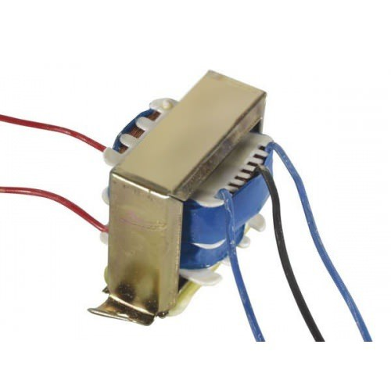

Fig: 2.2.1 Transformer

Basically, there are two sides in a transformer where the bend bowing inside the transformer closes. Both terminations have two wires each. On the transformer, one side will have three terminals and the other will have two. The one with the three terminals is the wandered down yield of the transformer, and the one with the two terminals is the place the data voltage is to be acclimated.

**Rectifier:**

Rectifier is a gadget which is utilized to change over AC voltage to DC voltage. It is for the most part separated into Full wave and Half wave rectifiers. At the point when forward one-sided there will be voltage drop in diodes of around 0.7v.

In this manner when two diodes are combined together for allowance of light of the path thee will be a voltage drop of 1.4v since every diode as a voltage drop of 0.7v. However, on account of full wave connect rectifier there will be a voltage drop of 0.7v as it were. The voltage controller needs 2 volts more than its yield voltage. For in the event that we are interfacing 12v connector for our motivation and henceforth we require 14v according to the yield voltage.

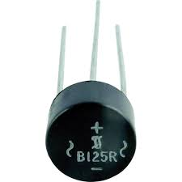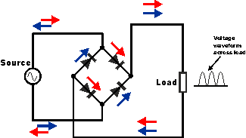

Fig: 2.2.2 Rectifier

So the yield of the diodes (which goes into the voltage controller) will must be more than or vague to 14 Volts. According to the diode data voltage the diode voltage in the voltage controller will be 14v. The voltage drop will be 1.4v totally, so the proportionate aggregate voltage will be 15.4 volts of which 14v in addition to 1.4v. so it is ideal to utilize 18 volt venture down transformer from 220 volt input voltage. In this manner transformer yield voltage will be of 3.4v of rough esteem.

**Capacitors:**

Capacitors are utilized to get the immaculate and smoothest DC voltage in which the rectifier is utilized to get throbbing DC voltage which is utilized as a part of the light of the present destiny, from the connector.

Capacitors are utilized to get square DC from AC current experience of the present channels so they are used as a touch of parallel to the yield. Moreover, if there is a swell in the data or yield, a capacitor changes it by discharging the charge set away in it.

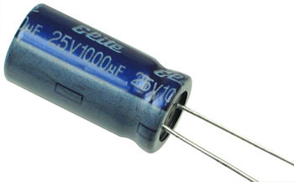

Fig: 2.2.3 Capacitor

**Voltage regulators:**

The 78XX voltage controller is principally overall utilized controller for voltage controllers. The XX speaks to the voltage of which the voltage controller delivers as the yield to the specific gadget. 7805 will deliver and control the yield voltage of 5v and 7812 will create the yield voltage of 12v. The voltage controllers are that they require no under 2 volts more than their yield voltage as information. For instance, 7805 will require no under 7V, and 7812, no under 14 volts as information sources. This voltage which ought to be given to voltage controllers is called Dropout Voltage.

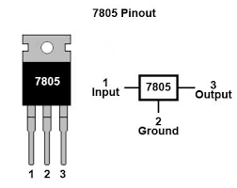

Fig: 2.2.4 Voltage Regulator

**3.1 Raspberry Pi:**

The Raspberry Pi is a credit-card sized computer that plugs into your TV and a keyboard. It is a capable little computer which can be used in electronics projects, and for many of the things that your desktop PC does, like spreadsheets, word-processing and games.

It also plays high-definition video. We want to see it being used by kids all over the world to learn how computers work, how to manipulate the electronic world around them, and how to program.

The Raspberry Pi is a low cost, **credit-card sized computer** that plugs into a computer monitor or TV, and uses a standard keyboard and mouse. It is a capable little device that enables people of all ages to explore computing, and to learn how to program in languages like Scratch and Python. It’s capable of doing everything you’d expect a desktop computer to do, from browsing the internet and playing high-definition video, to making spreadsheets, word-processing, and playing games.

What’s more, the Raspberry Pi has the ability to interact with the outside world, and has been used in a wide array of digital maker projects, from music machines and parent detectors to weather stations and tweeting birdhouses with infra-red cameras. We want to see the Raspberry Pi being used by kids all over the world to learn to program and understand how computers work.

There are currently four Raspberry Pi models. They are the Model A, the Model B, the Model B+ and the Compute Module. All models use the same CPU, the [BCM2835](http://www.raspberrypi.org/documentation/hardware/raspberrypi/bcm2835/README.md), but other hardware features differ.

The **Raspberry Pi** is a series of [credit card](https://en.wikipedia.org/wiki/Credit_card)-sized [single-board computers](https://en.wikipedia.org/wiki/Single-board_computer) developed in the [United Kingdom](https://en.wikipedia.org/wiki/United_Kingdom) by the [Raspberry Pi Foundation](https://en.wikipedia.org/wiki/Raspberry_Pi_Foundation) with the intent to promote the teaching of basic [computer science](https://en.wikipedia.org/wiki/Computer_science) in schools and [developing countries](https://en.wikipedia.org/wiki/Developing_countries). The original Raspberry Pi and Raspberry Pi 2 are manufactured in several board configurations through licensed manufacturing agreements with [Newark element14](https://en.wikipedia.org/wiki/Newark_element14) ([Premier Farnell](https://en.wikipedia.org/wiki/Premier_Farnell)), [RS Components](https://en.wikipedia.org/wiki/RS_Components) and Egoman. The hardware is the same across all manufacturers. The firmware is [closed-source](https://en.wikipedia.org/wiki/Closed-source).

Several generations of Raspberry Pi's have been released. The first generation (Pi 1) was released in February 2012 in basic model A and a higher specification model B. A+ and B+ models were released a year later. Raspberry Pi 2 model B was released in February 2015 and Raspberry Pi 3 model B in February 2016.

These boards are priced between 20 and 35 US$. A cut down compute model was released in April 2014 and a Pi Zero with smaller footprint and limited [IO](https://en.wikipedia.org/wiki/Input/output) ([GPIO](https://en.wikipedia.org/wiki/General-purpose_input/output)) capabilities released in November 2015 for 5 US$.

All models feature a [Broadcom](https://en.wikipedia.org/wiki/Broadcom) [system on a chip](https://en.wikipedia.org/wiki/System_on_a_chip) (SOC), which includes an [ARM compatible](https://en.wikipedia.org/wiki/ARM_architecture) [CPU](https://en.wikipedia.org/wiki/Central_processing_unit) and an on chip [graphics processing unit](https://en.wikipedia.org/wiki/Graphics_processing_unit) GPU (a [Video Core](https://en.wikipedia.org/wiki/VideoCore) IV). CPU speed ranges from 700 MHz to 1.2 GHz for the Pi 3 and on board memory range from 256 MB to 1 GB RAM. [Secure Digital](https://en.wikipedia.org/wiki/Secure_Digital) SD cards are used to store the operating system and program memory in either the SDHC or Micro SDHC sizes. Most boards have between one and four USB slots, [HDMI](https://en.wikipedia.org/wiki/HDMI) and [composite video](https://en.wikipedia.org/wiki/Composite_video) output, and a 3.5 mm phone jack for audio. Lower level output is provided by a number of GPIO pins which support common protocols like [I2C](https://en.wikipedia.org/wiki/I%C2%B2C). Some models have an RJ45 Ethernet port and the Pi 3 has on board Wi-Fi 802.11n and [Bluetooth](https://en.wikipedia.org/wiki/Bluetooth).

The Foundation provides Debian and Arch Linux ARM [distributions](https://en.wikipedia.org/wiki/Linux_distribution) for download, and promotes [Python](https://en.wikipedia.org/wiki/Python_%28programming_language%29) as the main programming language, with support for [BBC BASIC](https://en.wikipedia.org/wiki/BBC_BASIC)(via the [RISC OS](https://en.wikipedia.org/wiki/RISC_OS) image or the Brandy Basic clone for Linux), [C](https://en.wikipedia.org/wiki/C_%28programming_language%29), [C++](https://en.wikipedia.org/wiki/C%2B%2B), [PHP](https://en.wikipedia.org/wiki/PHP), [Java](https://en.wikipedia.org/wiki/Java_%28programming_language%29), [Perl](https://en.wikipedia.org/wiki/Perl), [Ruby](https://en.wikipedia.org/wiki/Ruby_%28programming_language%29), [Squeak](https://en.wikipedia.org/wiki/Squeak) Smalltalk and more also available.

In February 2016, the Raspberry Pi Foundation announced that they had sold eight million devices, making it the best-selling UK [personal computer](https://en.wikipedia.org/wiki/Personal_computer), ahead of the [Amstrad PCW](https://en.wikipedia.org/wiki/Amstrad_PCW).The Raspberry Pi hardware has evolved through several versions that feature variations in memory capacity and peripheral-device support.

[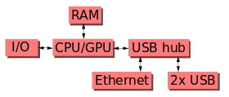](https://en.wikipedia.org/wiki/File:Raspberrypi_block_function_v01.svg)

Fig: 3.1 Block Diagram of Raspberry Pi

This block diagram depicts models A, B, A+, and B+. Model A,A+, and Zero lack the [Ethernet](https://en.wikipedia.org/wiki/Ethernet) and [USB](https://en.wikipedia.org/wiki/USB) hub components. The Ethernet adapter is connected to an additional USB port. In model A and A+ the USB port is connected directly to the SOC. On model B+ and later models the USB/Ethernet chip contains a five-point USB hub, of which four ports are available, while model B only provides two. On the model Zero, the USB port is also connected directly to the SOC, but it uses a micro USB (OTG) port.

**3.2 Performance of first generation models:**

While operating at 700 MHz by default, the first generation Raspberry Pi provided a real-world performance roughly equivalent to 0.041 [GFLOPS](https://en.wikipedia.org/wiki/FLOPS). On the [CPU](https://en.wikipedia.org/wiki/Central_processing_unit) level the performance is similar to a 300 MHz [Pentium II](https://en.wikipedia.org/wiki/Pentium_II) of 1997–99. The GPU provides 1 [G pixel](https://en.wikipedia.org/wiki/Gpixel)/s or 1.5 [G pixel](https://en.wikipedia.org/wiki/Texel_%28graphics%29)/s of graphics processing or 24 GFLOPS of general purpose computing performance. The graphics capabilities of the Raspberry Pi are roughly equivalent to the level of performance of the [Xbox](https://en.wikipedia.org/wiki/Xbox_%28console%29) of 2001.The [LINPACK](https://en.wikipedia.org/wiki/LINPACK) single node compute benchmark results in a mean [single precision performance](https://en.wikipedia.org/wiki/Single-precision_floating-point_format) of 0.065 GFLOPS and a mean [double precision performance](https://en.wikipedia.org/wiki/Double-precision_floating-point_format) of 0.041 GFLOPS for one Raspberry Pi Model-B board. A cluster of 64 Raspberry Pi Model-B computers, labeled "Iridis-pi", achieved a LINPACK [HPL](https://en.wikipedia.org/wiki/LINPACK_benchmarks#HPL) suite result of 1.14 GFLOPS (n=10240) at 216 [watts](https://en.wikipedia.org/wiki/Watt) for c. 4 000 US$. Raspberry Pi 2 is based on Broadcom BCM2836 SOC, which includes a quad-core Cortex-A7 CPU running at 900 MHz and 1 GB RAM. It is described as 4–6 times more powerful than its predecessor. The GPU is identical to the original.

#### **3.3 Over clocking:**

The first generation Raspberry Pi chip operated at 700 MHz by default, and did not become hot enough to need a [heat sink](https://en.wikipedia.org/wiki/Heat_sink) or special cooling unless the chip was over clocked. The second generation runs at 900 MHz by default; it also does not become hot enough to need a heat sink or special cooling, although [over clocking](https://en.wikipedia.org/wiki/Overclocking) may heat up the SOC more than usual.

Most Raspberry Pi chips could be over clocked to 800 MHz, and some to 1000 MHz There are reports the second generation can be similarly over clocked, in extreme cases, even to 1500 MHz (discarding all safety features and over-voltage limitations).

In the [Raspbian](https://en.wikipedia.org/wiki/Raspberry_Pi#Software)[Linux distro](https://en.wikipedia.org/wiki/Linux_distro) the over clocking options on [boot](https://en.wikipedia.org/wiki/Booting) can be done by a software command running "sudoraspi-config" without voiding the warranty.[[22]](https://en.wikipedia.org/wiki/Raspberry_Pi#cite_note-22) In those cases the Pi automatically shuts the over clocking down if the chip reaches 85 °C (185 °F), but it is possible to override automatic over-voltage and over clocking settings (voiding the warranty); an appropriately sized [heat sink](https://en.wikipedia.org/wiki/Heatsink) is needed to keep the chip from serious overheating.

Newer versions of the firmware contain the option to choose between five over clock ("turbo") presets that when used; attempt to maximize the performance of the SOC without impairing the lifetime of the board. This is done by monitoring the core temperature of the chip, the CPU load, and dynamically adjusting clock speeds and the core voltage. When the demand is low on the CPU or it is running too hot the performance is throttled, but if the CPU has much to do and the chip's temperature is acceptable, performance is temporarily increased with clock speeds of up to 1 GHz depending on the individual board and on which of the turbo settings is used.

**3.4 Seven over clock presets:**

* none; 700 MHz ARM, 250 MHz core, 400 MHz SDRAM, 0 over volt,
* modest; 800 MHz ARM, 250 MHz core, 400 MHz SDRAM, 0 over volt,
* medium; 900 MHz ARM, 250 MHz core, 450 MHz SDRAM, 2 over volt,
* high; 950 MHz ARM, 250 MHz core, 450 MHz SDRAM, 6 over volt,
* turbo; 1000 MHz ARM, 500 MHz core, 600 MHz SDRAM, 6 over volt,
* Pi2; 1000 MHz ARM, 500 MHz core, 500 MHz SDRAM, 2 over volt,
* Pi3; 1100 MHz ARM, 550 MHz core, 500 MHz SDRAM, 6 over volt. In system information CPU speed will appear as 1200 MHz When in idle speed lowers to 600 MHz

In the highest (turbo) preset the SDRAM clock was originally 500 MHz, but this was later changed to 600 MHz because 500 MHz sometimes causes SD card corruption. Simultaneously in high mode the core clock speed was lowered from 450 to 250 MHz, and in medium mode from 333 to 250 MHz frequency. The Raspberry Pi Zero runs at 1 GHz.

### **3.5RAM:**

On the older beta model B boards, 128 MB was allocated by default to the GPU, leaving 128 MB for the CPU. On the first 256 MB release model B (and model A), three different splits were possible. The default split was 192 MB (RAM for CPU), which should be sufficient for standalone 1080p video decoding, or for simple 3D, but probably not for both together. 224 MB was for Linux only, with only a 1080p [frame buffer](https://en.wikipedia.org/wiki/Framebuffer), and was likely to fail for any video or 3D. 128 MB was for heavy 3D, possibly also with video decoding (e.g. XBMC). Comparatively the Nokia 701 uses 128 MB for the Broadcom Video Core IV. For the new model B with 512 MB RAM initially there were new standard memory split files released( arm256_start.elf, arm384_start.elf, arm496_start.elf) for 256 MB, 384 MB and 496 MB CPU RAM (and 256 MB, 128 MB and 16 MB video RAM). But a week or so later the RPF released a new version of start.elf that could read a new entry in config.txt (gpu_mem=xx) and could dynamically assign an amount of RAM (from 16 to 256 MB in 8 MB steps) to the GPU, so the older method of memory splits became obsolete, and a single start.elf worked the same for 256 and 512 MB Raspberry Pis. The Raspberry Pi 2 and the Raspberry Pi 3 have 1 GB of RAM. The Raspberry Pi Zero has 512 MB of RAM.

### **3.6Networking:**

Though the model A and A+ and Zero do not have an [8P8C](https://en.wikipedia.org/wiki/8P8C) ("RJ45") Ethernet port, they can be connected to a network using an external user-supplied USB Ethernet or [Wi-Fi](https://en.wikipedia.org/wiki/Wi-Fi) adapter.

On the model B and B+ the Ethernet port is provided by a built-in USB Ethernet adapter using the SMSC LAN9514 chip.[[29]](https://en.wikipedia.org/wiki/Raspberry_Pi#cite_note-SMSC-LAN9514-specs-29) The Raspberry Pi 3 is equipped with 2.4 GHz WI-Fi[802.11n](https://en.wikipedia.org/wiki/IEEE_802.11n-2009)(600 M bit/s) and [Bluetooth 4.1](https://en.wikipedia.org/wiki/Bluetooth_4.1)(24 M bit/s) in addition to the 10/100 Ethernet port.

**3.7Power supply:**

The Raspberry Pi is powered by the small micro-USB connector found on the lower left side of the circuit board. This connectors the same as found on the majority of smart phones and some tablet devices. Many chargers designed for smart phones will work with the Raspberry Pi, but not all. The Pi is more power-hungry than most micro-USB devices, and requires up to 700mA in order operating. Some chargers can only supply up to 500mA, causing in termittent problems in the Pi’s operation. Connecting the Pi to the USB port on a desktop or laptop computer is possible, but not recommended. As with smaller chargers, the USB ports on a computer can’t provide the power required for the Pi to work properly. Only connect the micro-USB power supply when you are ready to start using the Pi. With no power button on the device, it will start working the instant power is connected and can only be turned off again by physically removing the power cable.

### **3.8Peripherals**:

The Raspberry Pi may be operated with any generic USB [computer keyboard](https://en.wikipedia.org/wiki/Computer_keyboard) and [mouse](https://en.wikipedia.org/wiki/Mouse_%28computing%29), Video. The video controller is capable of standard modern TV resolutions, such as HD and Full HD, and higher or lower monitor resolutions and older standard CRT TV resolutions. As shipped (i.e. without custom over clocking) it is capable of the following: 640×350 [EGA](https://en.wikipedia.org/wiki/Enhanced_Graphics_Adapter); 640×480 [VGA](https://en.wikipedia.org/wiki/Video_Graphics_Array); 800×600 [SVGA](https://en.wikipedia.org/wiki/Super_video_graphics_array); 1024×768 [XGA](https://en.wikipedia.org/wiki/XGA); 1280×720 [720p](https://en.wikipedia.org/wiki/720p)[HDTV](https://en.wikipedia.org/wiki/High-definition_television#High-definition_display_resolutions); 1280×768 [WXGA](https://en.wikipedia.org/wiki/Graphic_display_resolutions#WXGA) variant; 1280×800 [WXGA](https://en.wikipedia.org/wiki/Graphic_display_resolutions#WXGA) variant; 1280×1024 [SXGA](https://en.wikipedia.org/wiki/SXGA); 1366×768 [WXGA](https://en.wikipedia.org/wiki/Graphic_display_resolutions#WXGA) variant; 1400×1050 [SXGA+](https://en.wikipedia.org/wiki/SXGA%2B); 1600×1200 [UXGA](https://en.wikipedia.org/wiki/UXGA); 1680×1050 [WXGA+](https://en.wikipedia.org/wiki/WXGA%2B); 1920×1080 [1080p](https://en.wikipedia.org/wiki/1080p)[HDTV](https://en.wikipedia.org/wiki/High-definition_television#High-definition_display_resolutions); 1920×1200 [WUXGA](https://en.wikipedia.org/wiki/WUXGA).[[31]](https://en.wikipedia.org/wiki/Raspberry_Pi#cite_note-video-31)Higher resolutions, such as, up to 2048×1152, may work or even 3840×2160 at 15 Hz (too low a frame rate for convincing video). Note also that allowing the highest resolutions does not imply that the GPU can decode video formats at those; in fact, the Pis are known to not work reliably for [H.265](https://en.wikipedia.org/wiki/H.265) (at those high resolution, at least), commonly used for very high resolutions (most formats, commonly used, up to full HD, do work).

Although the Raspberry Pi 3 does not have H.265 decoding hardware, the CPU, more powerful than its predecessors, is potentially able to decode H.265-encoded videos in software. The Open Source Media Center ([OSMC](https://en.wikipedia.org/wiki/OSMC)) project said in February 2016:

The new BCM2837 based on 64-bit ARMv8 architecture is backwards compatible with the Raspberry Pi 2 as well as the original. While the new CPU is 64-bit, the Pi retains the original Video Core IV GPU which has a 32-bit design. It will be a few months before work is done to establish 64-bit pointer interfacing from the kernel and user land on the ARM to the 32-bit GPU. As such, for the time being, we will be offering a single Raspberry Pi image for Raspberry Pi 2 and the new Raspberry Pi 3.

Only when 64-bit support is ready, and beneficial to OSMC users, will we offer a separate image. The new quad core CPU will bring smoother GUI performance. There have also been recent improvements to H265 decoding. While not hardware accelerated on the Raspberry Pi, the new CPU will enable more H265 content to be played back on the Raspberry Pi than before. Raspberry Pi 3 announced with OSMC support.

The Pi 3's GPU has higher clock frequencies—300 MHz and 400 MHz for different parts—than previous versions' 250 MHz. The Pis can also generate [576i](https://en.wikipedia.org/wiki/576i) and [480i](https://en.wikipedia.org/wiki/480i)[composite video](https://en.wikipedia.org/wiki/Composite_video) signals, as used on old-style ([CRT](https://en.wikipedia.org/wiki/Cathode_ray_tube)) TV screens, (through non-standard connectors, different kind depending on models) for [PAL-BGHID](https://en.wikipedia.org/wiki/PAL#PAL-B.2FG.2FD.2FK.2FI), [PAL-M](https://en.wikipedia.org/wiki/PAL-M), [PAL-N](https://en.wikipedia.org/wiki/PAL-N), [NTSC](https://en.wikipedia.org/wiki/NTSC) and [NTSC-J](https://en.wikipedia.org/wiki/NTSC-J).

**3.9Real-time clock:**

The Raspberry Pi does not have a built-in [real-time clock](https://en.wikipedia.org/wiki/Real-time_clock), and does not "know" the time of day. As alternatives, a program running on the Pi can get the time from a [network time server](https://en.wikipedia.org/wiki/Network_Time_Protocol) or user input at boot time, thus knowing the time while powered on. A real-time hardware clock with battery backup, such as the DS1307, which is fully binary coded, may be added (often via the [I²C](https://en.wikipedia.org/wiki/I%C2%B2C) interface).

**3.10 Raspberry Pi 2 Model B:**

The Raspberry Pi 2 delivers 6 times the processing capacity of previous models. This second generation Raspberry Pi has an upgraded Broadcom BCM2836 processor, which is a powerful ARM Cortex-A7 based quad-core processor that runs at 900MHz. The board also features an increase in memory capacity to 1Gbyte.

**Specifications:**

Chip :Broadcom BCM2836 SOC

Core architecture :Quad-core ARM Cortex-A7

CPU :900 MHz

GPU :Dual Core Video Core IV® Multimedia Co-Processor

Provides Open GL ES 2.0, hardware-accelerated OpenVG,

and 1080p30 H.264 high-profile decode Capable of 1Gpixel/s,

1.5Gtexel/s or 24GFLOPs with texture filtering and

DMA infrastructure

Memory :1GB LPDDR2

OS :Boots from Micro SD card, running a version of the Linux

operating system.

Dimensions :85 x 56 x 17mm

Power :Micro USB socket 5V, 2A

**Connectors:**

Ethernet :10/100 Base T Ethernet socket

Video Output :HDMI (rev 1.3 & 1.4)

Audio Output :3.5mm jack, HDMI

USB :4 x USB 2.0 Connector

GPIO Connector :40-pin 2.54 mm (100 mil) expansion header: 2x20 strip

Providing 27 GPIO pins as well as +3.3 V, +5 V and GND

supply lines

Camera Connector :15-pin MIPI Camera Serial Interface (CSI-2)

JTAG :Not populated Display Connector: Display Serial Interface (DSI)

15 way flat flex cable connector with two data lanes and a clock lane

Memory Card Slot :Micro SDIO

The Raspberry Pi is a small, powerful and lightweight ARM based computer which can do many of the things a desktop PC can do. The powerful graphics capabilities and HDMI video output make it ideal for multimedia applications such as media centers and narrowcasting solutions. The Raspberry Pi is based on a Broadcom BCM2835 chip.

It does not feature a built-in hard disk or solid-state drive, instead relying on an SD card for booting and long-term storage.



Fig: 3.10 Raspberry Pi model B

**3.11 General purpose input/output pins on the raspberry pi:**

GPIO pins can be configured as either general-purpose input, general-purpose output or as one of up to 6 special alternate settings, the functions of which are pin-dependant. There are 3 GPIO banks on BCM2836.

Each of the 3 banks has its own VDD input pin. On Raspberry Pi, all GPIO banks are supplied from 3.3V.

Connection of a GPIO to a voltage higher than 3.3V will likely destroy the GPIO block within the SOC. A selection of pins from Bank 0 is available on the P1 header on Raspberry Pi.

**4.1 GPIO Pads:**

The GPIO connections on the BCM2835 package are sometimes referred to in the peripherals datasheet as "pads" - a semiconductor design term meaning "chip connection to outside world".

The pads are configurable CMOS push-pull output drivers/input buffers. Register-based control settings are available for

* Internal pull-up / pull-down enable/disable
* Output drive strength
* Input Schmitt-trigger filtering



Fig: 4.1.1GPIO pins

These pins are a physical interface between the Pi and outside world. At the simplest levels, they are the switches that can turn on or off (input) or that the Pi can turn ON or OFF (output). Out of the 26 pins, 3 pins have been used to control three devices in this project which have been represented by 3 LEDs for testing the switching signal. For practical purposes a relay driver circuit and relays can be interfaced with Raspberry Pi and appliances, respectively, for their controlling.



Fig: 4.1.2 Pin Layout of Raspberry Pi GPIO Used in System

**4.2 Power-On States:**

All GPIOs revert to general-purpose inputs on power-on reset. The default pull states are also applied, which are detailed in the alternate function table in the ARM peripherals datasheet. Most GPIOs have a default pull applied.

**4.3 Interrupts:**

Each GPIO pin, when configured as a general-purpose input, can be configured as an interrupt source to the ARM. Several interrupt generation sources are configurable:

* Level-sensitive (high/low)
* Rising/falling edge
* Asynchronous rising/falling edge

Level interrupts maintain the interrupt status until the level has been cleared by system software (e.g. by servicing the attached peripheral generating the interrupt).

The normal rising/falling edge detection has a small amount of synchronization built into the detection. At the system clock frequency, the pin is sampled with the criteria for generation of an interrupt being a stable transition within a 3-cycle window, i.e. a record of "1 0 0" or "0 1 1". Asynchronous detection bypasses this synchronization to enable the detection of very narrow events.

**4.4 Alternative Method:**

Almost all of the GPIO pins have alternative functions. Peripheral blocks internal to BCM2835 can be selected to appear on one or more of a set of GPIO pins, for example the I2C busses can be configured to at least 3 separate locations. Pad control, such as drive strength or Schmitt filtering, still applies when the pin is configured as an alternate function. For more detailed information see the [Low level peripherals](http://elinux.org/RPi_Low-level_peripherals) page on the elinux iki. There are 54 general-purpose I/O (GPIO) lines split into two banks. All GPIO pins have at least two alternative functions within BCM. The alternate functions are usually peripheral IO and a single peripheral may appear in each bank to allow flexibility on the choice of IO voltage. Details of alternative functions are given in section 6.2. Alternative Function Assignments.

The block diagram for an individual GPIO pin is given below:



Fig: 4.4 Block Diagram of GPIO

**4.5Individual GPIO pin:**

The GPIO peripheral has three dedicated interrupt lines. These lines are triggered by the setting of bits in the event detect status register. Each bank has its’ own interrupt line with the third line shared between all bits. The Alternate function table also has the pull state (pull-up/pull-down) which is applied after a power down.

**5.1 UART:**

The BCM2835 device has two UARTS. On mini UART and and PL011 UART. This section describes the PL011 UART. For details of the mini UART see 2.2 Mini UART.

The PL011 UART is a Universal Asynchronous Receiver/Transmitter. This is the ARM UART (PL011) implementation. The UART performs serial-to-parallel conversion on data characters received from an external peripheral device or modem, and parallel-to-serial conversion on data characters received from the Advanced Peripheral Bus (APB).

**5.2 The UART provides:**

* Separate 16x8 transmit and 16x12 receive FIFO memory.
* Programmable baud rate generator.
* Standard asynchronous communication bits (start, stop and parity). These are added
* Prior to transmission and removed on reception.
* False start bit detection.
* Line breaks generation and detection.
* Support of the modem control functions CTS and RTS. However DCD, DSR, DTR and RI are not supported.
* Programmable hardware flow control.

**5.3 Fully-programmable serial interface characteristics:**

* Data can be 5, 6, 7, or 8 bits
* Even, odd, stick, or no-parity bit generation and detection
* 1 or 2 stop bit generation
* Baud rate generation, dc up to UARTCLK/16

The UART clock source and associated dividers are controlled by the Clock Manager. For the in-depth UART overview, please, refer to the ARM Prime Cell UART (PL011).

##### 5.4Baud Rate Error:

Try using a slower BAUD rate (or a single 0xFF byte which only has the start bit low) and see if it works.  We had a problem using 115k2 baud rate where our microcontroller communicating with the RPi could hit 113636baud or 119047baud.113636baud had the lowest error margin so we used it and TX from the RPi being received by the microcontroller worked fine.  However when transmitting to the RPi nothing was ever received. Changing the microcontroller to use 119047baud caused RX to work. We then tested the RPi transmitting a byte of 0×00 and measured the low state on a scope we got 78uS, showing an actual baud rate of 115384 from the RPi (8bits + the start bit all low).  This was odd as 113636baud still had to lower error margin but that was the finding. Are you over or under clocking the RPi? If so do you need to adjust the baud rate to compensate for this.

# 5.5 Enabling the UART port on a Raspberry PI:

By default the serial port on the Raspberry PI is configured for console input/output. If you wish to use the serial port in your own software then you must make the following changes. First use nano to open /boot/cmdline.txt and edit it to disable boot info being sent to the port.

$sudonano /boot/cmdline.txt

The contents of the file should look a bit like this:

dwc_otg.lpm_enable=0 console=ttyAMA0,115200kgdboc=ttyAMA0,115200 console=tty1 root=/dev/mmcblk0p2 rootfstype=ext4 elevator=deadline rootwait

Remove the text highlighted in red, this will stop boot infor being sent on startup. Press Ctrl+O to write the changes and Ctrl+X to exit nano.

Now we need to edit /etc/inittab to disable console login on the serial port. Open this file with nano

$sudonano /etc/inittab

T0:23:respawn:/sbin/getty -L ttyAMA0 115200 vt100 and comment it out by adding # to the start of it. You can then save this file and exit nano like you did before.

Now you have made these changes we can reboot the Raspberry PI.

$sudo reboot

Your serial port should now be ready for you to use in your own software.

**5.6Universal SPI Master (2x):**

The Raspberry Pi is equipped with one [SPI](http://en.wikipedia.org/wiki/Serial_Peripheral_Interface_Bus) bus that has 2 chip selects.

The SPI master driver is disabled by default on Raspian. To enable it, remove the blacklisting for spi-bcm2708 in/etc/modprobe.d/raspi-blacklist.conf, or use [raspi-config](http://www.raspberrypi.org/documentation/configuration/raspi-config.md). Reboot or load the driver manually with:

$ sudomodprobe spi-bcm2708

The SPI bus is available on the P1 Header:

MOSI P1-19

MISO P1-21

SCLK P1-23 P1-24 CE0

GND P1-25 P1-26 CE1

**5.7 Raspbian:**

Raspbian is the recommended operating system for normal use on a Raspberry Pi. Raspbian is a free operating system based on Debian, optimized for the Raspberry Pi hardware. Raspbian comes with over 35,000 packages; precompiled software bundled in a nice format for easy installation on your Raspberry Pi.

Raspbian is a community project under active development, with an emphasis on improving the stability and performance of as many Debian packages as possible.

**6.1 Installing Operating System Images:**

Installation of a Raspberry Pi Operating System image on an SD card requires another computer with an SD card reader to install the image.We recommend most users download [NOOBS](http://www.raspberrypi.org/documentation/installation/noobs.md) which is designed to be very easy to use. However more advanced users looking to install a particular image should use this guide.



Fig: 6.1 Raspberry pi board

**6.2 SD Card:**

An SD (Secure Digital) card is a storage device that has many useful features depending on how and where it's used. I can add an SD card to a small device, like a mobile phone, to extend the storage space available for ringtones, texts, apps, music and other data. It does not include a built in hard disk, but uses an SD card for booting and persistent storage. As the RPi has no internal storage or built-in operating system it requires an SD-Card that is set up to boot the RPi. I can create my own preloaded card using any suitable SD card I have.

**6.3 Keyboard & Mouse:**

Most standard USB keyboards and mice will work with the RPi. Wireless keyboard/mice should also function, and only require a single USB port for an RF dongle. In order to use a Bluetooth keyboard or mouse it would need to use a Bluetooth dongle, which again uses a single port. Remember that the Model A has a single USB Port and the Model B only have two (typically a keyboard and mouse will use a USB port each).

**6.4 Display:**

There are two main connection options for the RPi display, HDMI (high definition) and Composite (low definition).

HD TVs and most LCD Monitors can be connected using a full-size 'male' HDMI cable, and with an inexpensive adaptor if DVI is used. HDMI versions 1.3 and 1.4 are supported, and a version 1.4 cable is recommended. The RPi outputs audio and video via HMDI, but does not support HDMI input.

Older TVs can be connected using Composite (a yellow-to-yellow cable) or via SCART (using a Composite to SCART adaptor). PAL and NTSC TVs are supported. When using composite video, audio is available from a 3.5mm (1/8 inch) socket, and can be sent to your TV, to headphones, or to an amplifier. To send audio your TV, you will need a cable which adapts from 3.5mm to double (red and white) RCA connectors.

There is no VGA output available, so older VG A monitors will require an expensive adaptor. Using an HDMI to DVI-D (digital) adaptor plus a DVI to VGA adaptor will not work. HDMI does not supply the DVI-A (analogue) needed to convert to VGA - converting an HDMI or DVI-D source to VGA (or component) needs an active converter. (It can work out cheaper to buy a new monitor.) The lack of VGA has been acknowledged as a priority issue. There are currently four Raspberry Pi models. They are the Model A, the Model B, the Model B+ and the Compute Module. All models use the same CPU, the BCM2835, but other hardware features differ.

**7.1 The Model B+:**

Released in July 2014, the Model B+ is an updated revision of the Model B. It increases the number of USB ports to 4 and the number of pins on the GPIO header to 40. In addition, it has improved power circuitry which allows higher powered USB devices to be attached and now hot plugged. The full size composite video connector has been removed and the functionality moved to the 3.5mm audio/video jack. The full size SD card slot has also been replaced with a much more robust micro SD slot.

The following list details some of the improvements over the Model B.

* Current monitors on the USB ports mean the B+ now supports hot plugging.
* Current limiter on the 5V for HDMI means HDMI cable powered VGA converters will now all work
* 14 more GPIO pins
* EEPROM readout support for the new HAT expansion boards
* Higher drive capacity for analog audio out, from a separate regulator, which means a better audio DAC quality.
* No more back powering problems, due to the USB current limiters which also inhibit back flow, together with the "ideal power diode"
* Composite output moved to 3.5mm jack
* Connectors now moved to two sides of the board rather than the four of the original device.
* Ethernet LED's moved to the Ethernet connector
* 4 squarely positioned mounting holes for more rigid attachment to cases etc.
* The power circuit changes also means a reduction in power requirements of between 0.5W and 1W.

**7.2 Product Description:**

The Raspberry Pi Model B+ incorporates a number of enhancements and new features. Improved power consumption, increased connectivity and greater IO are among the improvements to this Powerful, small and lightweight ARM based computer.

**7.3 Connectors:**

Ethernet : 10/100 Base-T Ethernet socket

Video Output : HDMI (rev 1.3 & 1.4), Composite RCA (PAL and NTSC)

Audio Output : 3.5mm jack, HDMI

USB : 4 x USB 2.0 Connector

GPIO Connector : 40-pin 2.54 mm (100 mil) expansion header: 2x20 strip

Providing 27 GPIO pins as well as +3.3 V, +5 V and GND supply

lines

Camera Connector : 15-pin MIPI Camera Serial Interface (CSI-2)

JTAG : Not populated

Display Connector : Display Serial Interface (DSI) 15 way flat flex cable

connector with two data lanes and a clock lane

Memory Card Slot : Micro SDIO

**7.4 Specifications:**

Chip Broadcom : BCM2835 SOC

Core architecture : ARM11

CPU : 700 MHz Low Power ARM1176JZFS Applications Processor

GPU : Dual Core Video Core IV® Multimedia Co-Processor

Memory : 512MB SDRAM

Operating System : Boots from Micro SD card, running a version of the Linux

Dimensions : 85 x 56 x 17mm

Power : Micro USB socket 5V, 2A

Ethernet : 10/100 Base-T Ethernet socket

Video Output : HDMI (rev 1.3 & 1.4)

Composite RCA (PAL and NTSC)

Audio Output : 3.5mm jack, HDMI

USB : 4 x USB 2.0 Connector

GPIO Connector : 40-pin 2.54 mm (100 mil) expansion header: 2x20 strip

Providing 27 GPIO pins as well as +3.3 V, +5 V and GND supply lines

Camera Connector : 15-pin MIPI Camera Serial Interface (CSI-2)

JTAG : Not populated

Display Connector : Display Serial Interface (DSI) 15 ways flat flex cable connector

with two data lanes and a clock lane

Memory Card Slot : Micro SDIO

**7.5 The Compute Module:**

The compute module is intended for industrial applications, it is a cut down device which simply include the BCM2835, 512MB of SDRAM and a 4GB eMMC flash memory, in a small form factor. This connects to a base board using a repurposed 200 pin DDR2 SODIMM connector. Note the device is NOT SODIMM compatible, it just repurposes the connector. All the BCM2835 features are exposed via the SODIMM connector, including twin camera and LCD ports, whilst the Model A or B/B+ only have one of each.

The compute module is expected to be used by companies wishing to shortcut the development process of new product, meaning only a baseboard needs to be developed, with appropriate peripherals, with the Compute Module providing the CPU, memory and storage along with tested and reliable software.

**7.6 Schematics for Model B+:**

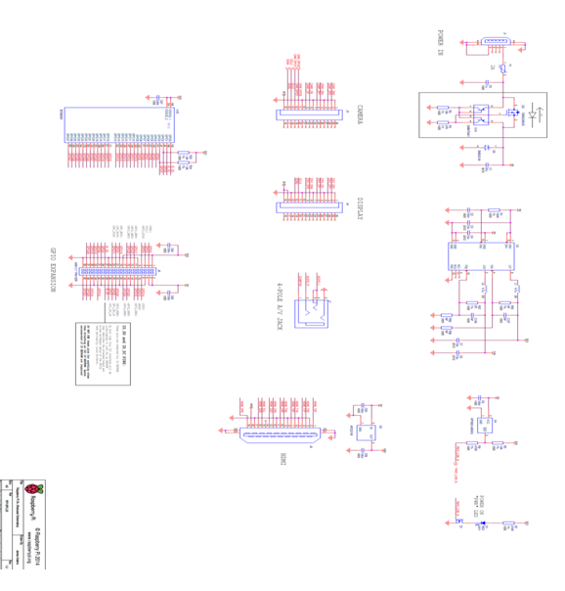

Fig: 7.6 Schematic Diagram of Model B+

**8.1 Relay:**

We know that most of the high end industrial application devices have relays for their effective working. Relays are simple switches which are operated both electrically and mechanically. Relays consist of a n electromagnet and also a set of contacts. The switching mechanism is carried out with the help of the electromagnet. There are also other operating principles for its working. But they differ according to their applications. Most of the devices have the application of relays.

**8.2 Importance of Relay**:

The main operation of a relay comes in places where only a low-power signal can be used to control a circuit. It is also used in places where only one signal can be used to control a lot of circuits. The application of relays started during the invention of telephones. They played an important role in switching calls in telephone exchanges. They were also used in long distance telegraphy. They were used to switch the signal coming from one source to another destination. After the invention of computers they were also used to perform Boolean and other logical operations. The high end applications of relays require high power to be driven by electric motors and so on. Such relays are called contactors.

**8.3 Relay Design:**

There are only four main parts in a relay. They are

* Electromagnet
* Movable Armature
* Switch point contacts
* Spring

The figures given below show the actual design of a simple relay.

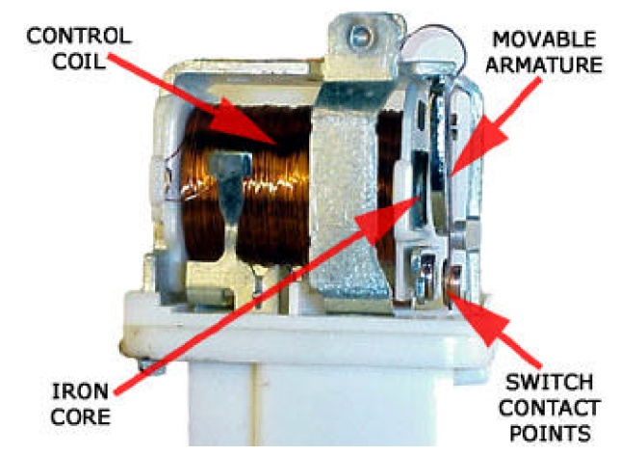

Fig: 8.3Construction of Relay

It is an electro-magnetic relay with a wire coil, surrounded by an iron core. A path of very low reluctance for the magnetic flux is provided for the movable armature and also the switch point contacts.  The movable armature is connected to the yoke which is mechanically connected to the switch point contacts. These parts are safely held with the help of a spring. The spring is used so as to produce an air gap in the circuit when the relay becomes de-energized.

**8.4 Working of Relay:**

The working of a relay can be better understood by explaining the following diagram given below.

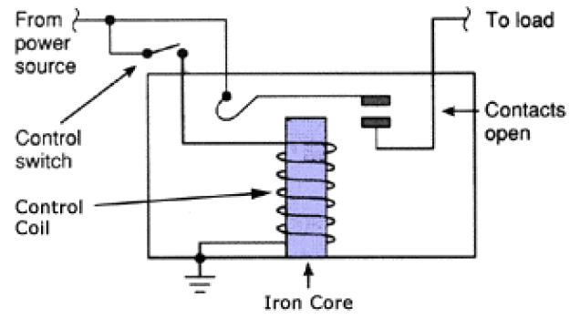

Fig: 8.4 Relay Design

The diagram shows an inner section diagram of a relay. An iron core is surrounded by a control coil. As shown, the power source is given to the electromagnet through a control switch and through contacts to the load. When current starts flowing through the control coil, the electromagnet starts energizing and thus intensifies the magnetic field.

Thus the upper contact arm starts to be attracted to the lower fixed arm and thus closes the contacts causing a short circuit for the power to the load. On the other hand, if the relay was already de-energized when the contacts were closed, then the contact move oppositely and make an open circuit.

As soon as the coil current is off, the movable armature will be returned by a force back to its initial position. This force will be almost equal to half the strength of the magnetic force. This force is mainly provided by two factors. They are the spring and also gravity.

Relays are mainly made for two basic operations. One is low voltage application and the other is high voltage.

For low voltage applications, more preference will be given to reduce the noise of the whole circuit. For high voltage applications, they are mainly designed to reduce a phenomenon called arcing.

**8.5Connection Of Single Pole Single Throw (SPST) Relay In Circuit:**

In order to know how to connect a single pole single throw (SPST) relay, you must know what each pin terminal represents and how the relay works.

### **Terminal Pins:**

A Single Pole Single Throw Relay comes with four terminal points. The terminals are COIL, COIL ,COM, and N.O.  
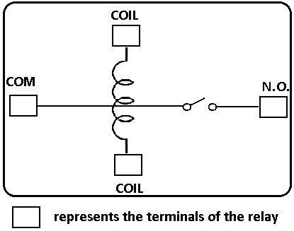

Fig:8.5 Terminals of relay

### **Terminal Descriptions:**

**COIL**- This is one end of the coil.

**COIL**- This is the other end of the coil. These are the terminals where you apply voltage to in order to give power to the coils (which then will close the switch). Polarity does not matter. One side gets positive voltage and the other side gets negative voltage. Polarity only matters if a diode is used.

**NO**- This is Normally Open switch. This is the terminal where you connect the device that you want the relay to power when the relay is powered, meaning when the COIL receives sufficient voltage. The device connected to NO will be off when the relay has no power and will turn on when the relay receives power.

**COM**- This is the common of the relay. If the relay is powered and the switch is closed, COM and N.O. have continuity. This is the terminal of the relay where you connect the first part of your circuit to.

**8.6Connection Of DPDT Relay In a Circuit:**

In order to know how to connect a DPDT relay, you must know what each pin terminal represents and how the relay works.

### **Terminal Pins:**

A Double Pole Double Throw Relay comes with 8 terminal points. The terminals are COIL, COIL, COM, COM, NO, NO, NC, NC.

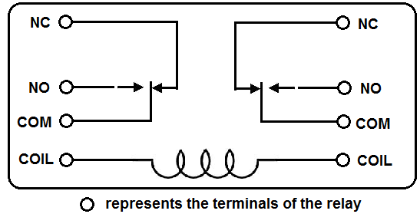

Fig: 8.6.1 Terminals of DPDT

This correlates to the following in the relay:

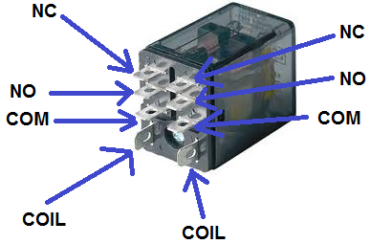

Fig: 8.6.2 DPDT

### **Terminal Descriptions:**

**COIL**- This is the COIL terminal. These are the terminals where you apply voltage to in order to give power to the coils (which then will close the switch). Polarity does not matter. One side gets positive voltage and the other side gets negative voltage. It doesn't matter which order. Polarity only matters if a diode is used.

**NO**- This is Normally Open switch. This is the terminal where you connect the device that you want the relay to power, when the relay is powered, meaning when the COIL receives sufficient voltage. The device connected to NO will be off when the relay has no power and will turn on when the relay receives power.

**NC**- This is the Normally Closed Switch. This is the terminal where you connect the device that you want powered when the relay receives no power. The device connected to NC will be on when the relay has no power and will turn off when the relay receives power.

**COM**- This is the common of the relay. If the relay is powered and the switch is closed, COM and NO have continuity. If the relay isn't powered and the switch is open, COM and NC have continuity. This is the terminal of the relay where you connect the first part of your circuit to.

Since the relay is rated for 12V, it should receive 12 volts in order to power on. It may work with less voltage, but 12V is really what it should receive. This goes into either side of the COIL terminals. Even if you switched the positive and negative voltage of the power supply, it should work exactly the same.

The COM terminals of the relay get connected to the first part of the circuit. If there is no first part of the circuit, this terminal can be left open. In this case, the first part of the circuit is the 5-volt power supply and the 9-volt power supply to light the LEDs and the DC fan and DC motor.

The NC terminals of the relay get power even when the relay isn't powered. This means that as long as the 5-volt power supply is on, the red LED and the DC fan will be on and operating.

The NO terminals of the relay get power only when the relay is powered. When the relay receives 12 volts of power, the relay snaps from the NC position to the NO position. The red LED and the DC fan now shut off and the green LED and the DC motor now turn on and operate.

**8.7SPDT RELAY:**

The Single Pole Double Throw SPDT relay is quite useful in certain applications because of its internal configuration. It has one common terminal and 2 contacts in 2 different configurations: one can be [Normally Closed](http://www.electroschematics.com/9595/normally-closed-relay-switch/) and the other one is opened or it can be [normally open](http://www.electroschematics.com/9593/normally-open-relay-switch/) and the other one closed. So basically you can see the SPDT relay as a way of switching between 2 circuits: when there is no voltage applied to the coil one circuit “receives” current, the other one doesn’t and when the coil gets energized the opposite is happening.

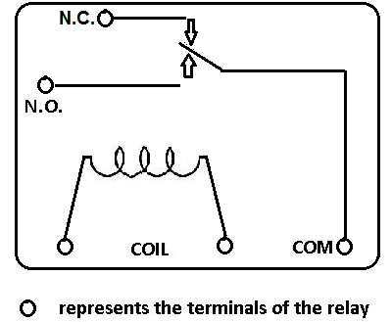

Fig: 8.7 Terminals of SPDT Relay

**8.8 Working Of Single Pole Double Throw relay:**

No DC voltage is applied to the coil so the terminal T is connected to contact 1 therefore the current can flow through 1 and it cannot flow through 2.When DC voltage is applied to the coil and terminal T is now connected to contact 2 therefore the current doesn’t flow anymore through 1 but now it flows through 2.

**9.1 GSM:**

GSM stands for Global System for Mobile Communications. It is a standard set developed by the European Telecommunications Standards Institute (ETSI) to describe protocols for second generation (2G) digital cellular networks used by mobile phones.A Modem is a device which modulates and demodulates signals as required to meet the communication requirements. It modulates an analog carrier signal to encode digital information, and also demodulates such a carrier signal to decode the transmitted information.

A GSM Modem is a device that modulates and demodulates the GSM signals and in this particular case 2G signals. The modem we are using is SIMCOM SIM900. It is a Tri-band GSM/GPRS Modem as it can detect and operate at three frequencies (EGSM 900 MHz, DCS 1800 MHz and PCS1900 MHz). Default operating frequencies are EGSM 900MHz and DCS 1800MHz.

Sim900 is a widely used in many projects and hence many variants of development boards for this have been developed. These development boards are equipped with various features to make it easy to communicate with the SIM900 module. Some boards provide only TTL interface while some boards include an RS232 interface and some others include an USB interface. If your PC has a serial port(DB9) you can buy a GSM Modem that has both TTL and RS232 interfacings in economy.

Sim900 GSM module used here consists of a TTL interface and an RS232 interface. The TTL interface allows us to directly interface with a microcontroller while the RS232 interface includes a MAX232 IC to enable communication with the PC. It also consists of a buzzer, antenna and SIM slot. Sim900 in this application is used as a DCE (Data Circuit-terminating Equipment) and PC as a DTE (Data Terminal Equipment).

**9.2Importance Of GSM :**

GSM Technology has grown so much, that literally there isn’t a place on earth where there is no GSM signal. In such a scenario GSM provides us a wide scope in controlling things remotely from any place just with our finger tips. GSM also provides ease to easily communicate in a more robust way.

A GSM module has an RS232 interface for serial communication with an external peripheral.

In this case, the transmit pin (Tx) of the computer’s Serial port is connected with the receive pin (Rx) of the GSM module’s RS-232 interface. The transmit pin (Tx) of the RS-232 of GSM module is connected to receive pin (Rx) of microcontroller’s serial transmission pin.

And the serial transmit pin of the microcontroller is connected to the receive pin of the computer’s Serial port. Therefore the commands and their results are transmitted and received in a triangular fashion as depicted below.

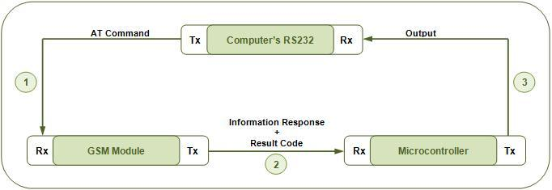

Fig: 9.2 GSM

In subsequent projects (see [MC075](http://www.engineersgarage.com/microcontroller/8051projects/interface-gsm-module-8051-microcontroller-circuit-code) & [MC076](http://www.engineersgarage.com/microcontroller/8051projects/interfacing-gsm-8051-microcontroller-circuit-code)), the HyperTerminal will be replaced by the microcontroller itself; thus avoiding the need of using a Computer to establish an interface. This would lead to an independent GSM based system.

The microcontroller is programmed to receive and transmit data at a baud rate of 9600. For more details on setting the baud rate of microcontroller, refer [serial communication with 8051](http://www.engineersgarage.com/microcontroller/8051projects/interface-serialport-RS232-AT89C51).

 The controller can receive data signals either by polling or by making use of serial interrupt (ES). Serial interrupt has been explained in [interrupt programming](http://www.engineersgarage.com/tutorials/8051-interrupts-programming). In polling, the controller continuously scans serial port for incoming data from the GSM module.

**10.1 Raspbian OS :**

Raspbian OS is one of the official Operating systems available for free to download and use. The system is based on Debian Linux and is optimized to work efficiently with the Raspberry Pi computer. As we already know an OS is a set of basic programs and utilities that runs on a specified hardware, in this case the Pi.

Debian is very lightweight and makes a great choice for the Pi. The Raspbian includes tools for browsing, python programming and a GUI desktop.

The Raspbian desktop environment is known as the “Lightweight X11 Desktop Environment” or in short LXDE.

This has a fairly attractive user interface that is built using the X Window System software and is a familiar point and click interface. We shall look more into how to install and use this OS in the next section.

## Setting Up Raspbian OS:

Let’s first connect the board with all the necessary accessories to install and run an operating system.

Step 1: Take the Pi out of its anti static cover and place it on the non-metal table.

Step 2: Connect the display – Connect the HDMI cable to the HDMI port on the Pi and the other end of the HDMI cable to the HDMI port of the TV.

Step 3: Connect your Ethernet cable from the Router to the Ethernet port on the Pi

Step 4: Connect your USB mouse to one of the USB ports on the Pi

Step 5: Connect your USB Keyboard to the other USB port on the Pi

Step 6: Connect the micro USB charger to the Pi but don’t connect it to the power supply yet

Step 7: Flash the SD Card with the Raspbian OS.

1. To prepare the car for use with the Pi we will need to put a OS on the card. We certainly cannot drag and drop the OS files on to the card but the flashing the card is not too difficult either.
2. Since we have already decided to install Raspbian, lets download the RASPBIAN image from the following link. http://www.raspberrypi.org/downloads/.
3. Unzip the contents of the Zip file into a folder on your machine, one of the unzipped files would be a .img file which is what needs to be flashed on to the SD card.[In case there are more than one file, the current version of the zip has only this file and none other]

**Flashing from Linux instructions:**

* 1. Start the terminal on your Linux OS
  2. Insert the empty SD Card into the card reader of your machine.
  3. Type sudo fdisk -l to see all the disks listed. Find the SD card by its size, and note the device address (/dev/sdX, where X is a letter identifying the storage device. Some systems with integrated SDcard readers may use /dev/mmcblkX— format, just change the target in the following instructions accordingly).
  4. Use cd to change to the directory with the .img file you extracted from the Zip archiv5.Type sudo dd if=imagefilename.img of=/dev/sdX bs=2M to write the file imagefilename.img to the SDcard connected to the device address. Replace imagefilename.img with the actual name of the file extracted from the Zip archive. This step takes a while, so be patient! During flashing, nothing will be shown on the screen until the process is fully complete.

**Flashing from Windows Instructions:**

The Image Writer for Windows is used in place of dd which designed specifically for creating USB or SD card images of Linux distributions, it features a simple graphical user interface that makes the creation of a Raspberry Pi SD card straight forward. Download the latest version of Image Writer for Windows from the website: <https://launchpad.net/win32-image-writer>. Below are the steps.

i. Download the binary (not source) Image Writer for Windows Zip file, and extract it to a folder on your computer.

ii. Plug your blank SD card into a card reader connected to the PC.

iii. Double-click the Win32DiskImager.exe file to open the program, and click the blue folder icon to open a file browse dialogue box.

iv. Browse to the imagefilename.img file you extracted from the distribution archive, replacing imagefilename.img with the actual name of the file extracted from the Zip archive, and then click the Open button.

v. Select the drive letter corresponding to the SD card from the Device drop-down dialogue box. If you’re unsure which drive letter to choose, open My Computer or Windows Explorer to check.

vi. Click the Write button to flash the image file to the SD card.

* 1. Once the OS is flashed, insert the SD card into the Pi SD Card slot
  2. Connect the Micro USB to the power source and switch it on.
  3. Now the system boots into the below screen and the LED’s on the board will Blink. Below is a small GIF showing the boot screen
  4. Now you will need to login with username/password combination of pi/raspberry.
  5. If you would like to use the GUI interface type startx. Below is the image showing the previous two steps.

**11.1 Existing Methods:**

IoT can be useful in wide range of applications like Smart home, smart cities, asset tracking and inventory control, shipping and location, Medical devices, security, individual tracking, and energy conservation. As already mentioned IoT allows communication between devices, commonly referred to as Machine-to-Machine (M2M) communication. With this possibility, physical devices can communicate to people letting them know their condition and where it is located. Devices such as trucks or ships allow the maximum capacity to be filled to the devices by communication amongst devices and then transferring that information to a person to capitalize on the information provided. All of these combined technologies maximize revenue by cutting cost of incapability within the business. Some of the existing methodologies include automated temperature control using LabVIEW and using a PWM system with a transistor, operated with a relay.

**11.2 Automated Temperature Control Using Lab View:**

The main object in temperature system is the reading of temperature value from LM35 temperature sensor. The primary use of LM35 temperature sensor is that it is the simplest of all the temperature sensors and it has an integrated circuit that gives an output as voltage that is proportional to the temperature in degree Celsius and the sensor itself deals with non-linear effects. LM35 sensor is connected directly with DAQ system. LabVIEW gets the signal from LM35 sensor as variable analog value. After processing, LabVIEW will send a cooling or heating signal to the system.

**11.3 Using a PWM System with a Transistor, Operated with a Relay:**

A relay is used to control the air conditioning in the house. A transistor is employed to turn on or off the respective relay. In the mechanism of temperature system programming, PWM system is utilized to control the heating and cooling devices. 5V DC power supply is used to operate LM35 sensor. TIP41 transistor because it has the ability to switch on/off for several pulse in its base in a little period of time. LM35 temperature sensor is used. This sensor is connected directly with DAQ LabVIEW reads the voltage signal from LM35 sensor as a variable analog value.

After processing the structure in the program, LabVIEW will send a signal as cooling or heating to the system, depending on the value of the sensor and the critical value of temperature that is required. In the mechanism of temperature system programming.

There might be many challenges to interface the LabVIEW software to other interfacing devices like the raspberry pi, arduino or the beagle bone black other than the NI modules like the NI Rio and the other devices of it’s class. Although connecting to the lab VIEW to the arduino may be possible, the interfacing of this device is quite a difficult task, establishing connection to the IoT cloud of many open source organization like IBM Watson, Amazon AWS etc, is quite a hectic task because of the reason that the IP address and the Physical address of the measuring component has to be determined or should be traced. Moreover these cloud services can communicate only through an MQTT protocol and hence, separate packages of MQTT for arduino has to install. A raspberry pi, can’t handle any lab VIEW program but, considered best for IoT purposes.

Temperature and humidity can be monitored as well as controlled, by the raspberry pi and is connected to the IoT. The data achieves can also be retrieved if the device is once connected to the IoT.

**12.1 Modified Method Temperature Control using Raspberry Pi Based On**

**IoT:**

POWER SUPPLY

RASPBERRY PI

GSM

FAN

RELAY

DHT11 SENSOR

Fig:12.1 Block Diagram of Temperature Control Using Raspberry Pi

The AC mains are fed to the transformer, which steps down the 230 Volts to the desired voltage.

The bridge rectifier follows the transformer thus converting AC voltage into a DC output and through a filtering capacitor feeds it directly into the input (Pin 1) of the voltage regulator.

The common pin (Pin 2) of the voltage regulator is grounded. The output (Pin 3) of the voltage regulator is first filtered by a capacitor, and then the output is taken. Make the circuit on a general purpose PCB and use a 2 Pin (5A) plug to connect the transformer input to the AC mains via insulated copper wires.When the temperature increases greater than the room temperature we will get SMS from the Raspberry Pi to our mobile through internet at that point we can switch on/off the devices by giving the reply to Raspberry Pi and we can observe the temperature in graph from by using think speak website.

**Applications:**

* More efficiency

**Advantages:**

* Secure

**12.2 Results and Analysis:**

When the temperature of the server room raises above the threshold valve then an SMS will be sent to the operator mobile from Raspberry PI by using GSM technology. Based on information received to the operator mobile and requirement of operation of fan, the operator gives reply to the SMS in the following format.

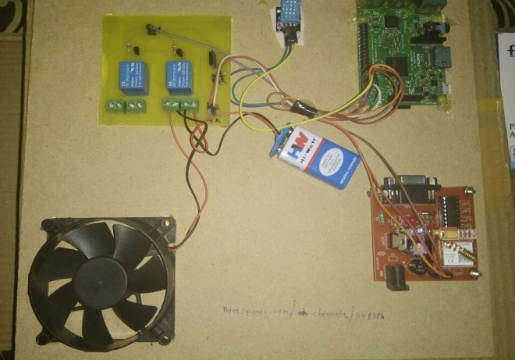

Fig : 12.2.1 Modified Method of Temperature Control

Using Raspberry Pi

**Results:**

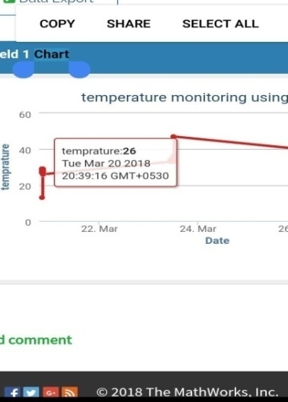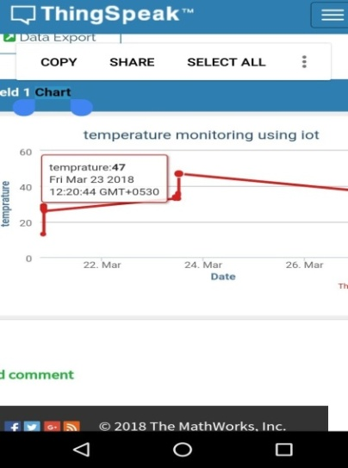

Fig : 12.2.2 Temperature Graph Shows the Below

and Above Room Temperature

* If the reply from the operator is ‘* , then that indicates the Raspberry PI to generate command for switching on the fan.
* If the reply from the operator is ‘#’, then that indicates the Raspberry PI generates the command for switching off the fan.

Based on the reply from the operator , Raspberry PI generates the command to change the state of the fan(ON/OFF) so as to control the temperature of the server room.

The raise/fall in temperature can be seen on a graph through internet connectivity i.e., in the website [www.thinkspeak.com](http://www.thinkspeak.com).

**Conclusion:**

Based on the current situation of the development, here is a new scheme of household temperature monitoring system. The monitoring hardware system is composed of raspberry pi, Wi-Fi dongle, DHT 11 sensor and an android mobile phone is used. This project deals with the automated temperature control. The results show that the proposed system has good feasibility. The best advantage is that it reduces the cost of monitoring system at the same time.

**References:**

1.Basil Ahammed, Design & Implementation of Smart House Control Using LabVIEW, International Journal of Soft Computing and Engineering (IJSCE), 1 (6), 2012.

2.Dingrong Yuan, Shenglong Fang, Yaqiong Liu, The design of smart home monitoring system based on WiFi electronic trash, Journal of Software, 9 (2), 2014, 425-428.

3.Jiansheng PENG W.L, Qiwen HE, Design of smart home system based on the wireless MCU CC2510, Journal of Hechi University, 10, 2008.

4.Patricio G, Gomes L, Smart house monitoring and actuating system development using automatic code generation, Industrial Informatics, 7th IEEE International Conference, 256-261, 2009, 23-26. VinaySagar K.N, Kusumab S.M, Home Automation using Internet of Things, IRJET, 02, 2015.